Build a Rollercoaster

Description: Students will explore Newton’s First Law as they create roller coasters.

Grade Level: K-4

Time Needed: 45-60 minutes

Standards/GLCE’s Covered: Grade K: Science- K-PS2-1, K-PS2-2
Grade 3: Science- 3-PS2-1, 3-PS2-2
Grade 4: Science- 4-PS3-1

SAFETY WARNINGS: Make sure that the ends of rollercoasters are not in walking paths. Students need to retrieve marbles if they fall off their track.

Materials:
- Foam Pipe Insulation
- Masking tape
- Marbles
- Scissors or box cutter
- Paper
- Pencils

Preparations before program: Cut insulation foam in half along the length so you have two half circles.

Procedure:
- Does anyone know how rollercoasters work? Typically, at the beginning of the rollercoaster, the cars that you sit in are mechanically brought to the top of a hill using a pulley system connected to a motor. Once the cars reach the top of the hill, the coaster will move on its own. Without assistance for the rest of the time! The rollercoaster itself does not actually have an engine.
- Rollercoasters work by converting potential energy (when at the top of the hill) into kinetic energy (or the energy of motion).
- They also work according to the law of inertia (Newton’s First law) which states “an object at rest stays at rest and an object in motion stays in motion with the same speed and in the same direction unless acted upon by an unbalanced force.” Inertia itself is the tendency of an object to resist changes in its state of motion.
- However, there are some forces that do act on the rollercoaster so the rollercoaster won’t keep running forever. Can anyone name what these may be? Gravity and friction both act on the cars of a rollercoaster and so does air resistance. When engineers design a rollercoaster, they must keep these factors in mind to make sure that the rollercoaster cars can maintain enough inertia to make it to the end of the track!
- You may also notice at the end of a rollercoaster, the track flattens for a bit. Breaks engage which increase friction, slowing the cars down. In addition, this flat track helps reduce the shifts between potential and kinetic energy.
- Now, students will put their knowledge to the test as they design and build a rollercoaster working in groups of three
- Divide students into their small groups. They will be using marbles and pipe insulation to build their coasters. They will need to think about inertia as they design and build their coasters. They will also have to act like real engineers. This will require a great deal of trial and error.
- Students should sketch their rollercoasters before they start building. They may use the stools or tables in the classrooms to use as bases for their rollercoaster. Each group will get three pieces of pipe insulation to work with. They should each get a roll of masking tape to use as well to stick their pieces together.
- When students have built their rollercoasters, they should test and alter their rollercoaster as needed. They may have to try a few times before their have their marble complete the track.
- If students finish early, challenge them to incorporate a new element into their design, like a loop or a twist.

Terminology and Definitions:
- Inertia: a property of matter by which it continues in its existing state of rest or uniform motion in a straight line, unless that state is changed by an external force.
- Newton’s First Law: “An object at rest stays at rest and an object in motion stays in motion with the same speed and in the same direction unless acted upon by an unbalanced force.”
- Force: a push or a pull on an object with mass that can cause it to change its velocity (to accelerate).
- Kinetic Energy: the energy that an object possesses due to its motion. It is defined as the work needed to accelerate a body of a given mass from rest to its stated velocity.
- Potential Energy: the stored energy in an object due to its position or its configuration.

References:
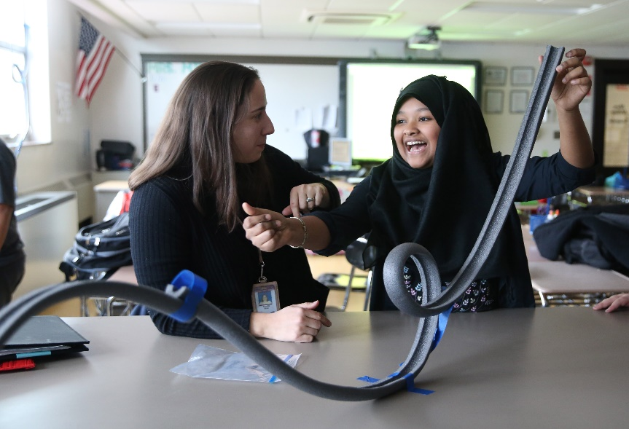

Additional Information:

How to extend: You can extend this lesson by having students explore centrifugal motion and incorporating loops or twists into their roller coasters.

Erosion in the Classroom

Abstract/Description: Students will learn about the process of erosion and build a device to help prevent beach erosion

Grade Level: 1-5

Time Needed: 45-60 minutes in presentation and experimentation

Standards/GLCE’s Covered: Grade 1: Social Studies-G5.0.1; Science- K-2-ETS1-2
Grade 2: Social Studies- G5.0.2; Science- 2-ESS2-1, K-2-ETS1-2
Grade 3: Science- 3-5-ETS1-2, 3-5-ETS1-3
Grade 4: Social Studies- G5.0.1; Science- 4-ESS3-2, 3-5-ETS1-2, 3-5-ETS1-3
Grade 5: Science- 3-5 ETS1-2, 3-5-ETS1-3

SAFETY WARNINGS: Students should not blow sand at people during class., and should wear safety googles to prevent sand from getting into eyes.

Materials:
- Plastic plant materials (fake plants)
- Craft sticks
- Plastic Loons
- Toothpicks
- Small pebbles
- Large pebbles
- Lego bricks
- Fake houses (monopoly)
- Something to create waves (empty water bottles)
- Plastic tubs
- Rulers
- Water
- Sand
- Towels

Preparations before program: Prepare the coastal tubs for the student groups and have each group have the same variables in the tubs (use the same amount of water and sand, place the animal habitat in the same location and also the houses). Divide the students into 6 groups. Create a resource table with all of the control method building materials. Make sure you have plenty of towels on hand.

Procedure:
- Create a beach erosion scenario which includes an area of housing and a wildlife habitat. For example the scenario we use is this: The poor city of Utopia is your client for today. They are experiencing a great deal of erosion along their shoreline, especially along their world famous sandy beaches. This is a large problem for Utopia as much of its economy is based on the tourists coming for the sandy beaches, and a lot of houses are located very near the shoreline. Additionally the erosion is also threatening an endangered loon habitat which is the largest location of Utopian Loons. As a team your group must create a plan to help the town manage its erosion problem.
- Explain that the students will be using their problem solving skills as a group to help build a solution for the beach erosion problem. Feel free to use local examples, or place your scenario in a local area. Being in the Great Lakes region we use Loons as our wildlife for the habitat area.
- Discuss erosion. Erosion is the gradual destruction of land forms through wind, water, or other natural means. This is not a quick process but it can be very destructive.
- As storms get worse, waves and winds have increased and taken more and more pieces of coast and shore away. Now this isn’t only a problem for places on the east and west coasts. This is also a problem everywhere. Talk about local erosion problems, either lakeshore or river shore. Discuss what some of the problems could be for people living in those areas.
- Talk about different types of erosion control methods and the advantages and disadvantages of each. Provide examples for the following: seawall, Rip Rap, Groyne, Breakwater and Soft armor. Also provide pictures of each type of control method. Discuss the drawbacks of each control method.
- Tell the students that they will work as a team of environmental engineers to determine which solution or solutions would be best for the given scenario. Remind them of any restrictions they need to be concerned about, like beach access for tourists or water access for wildlife in the reserve. Have the different groups brainstorm and sketch their ideas for their erosion control method(s) before they start experimenting with the tub.
- Demonstrate how to make waves with the empty water bottle (gently push it up and down in the water). Let the students practice their wave action so that they get the hang of how the waves are impacting the shoreline. Have the groups work together to determine best methods for erosion control with the different pieces provided. Give students 30 minutes to work on a solution and test their design.
- After their testing time students should help clean up by taking their control methods out of the water and place them onto the towels on their table.

Terminology and Definitions:
- Erosion: the gradual destruction of land forms through the means of wind, water or other natural methods.
- Seawall: a rigid structure made of cement or other hard substances, placed parallel to the shoreline.
- Rip Rap: Large boulders or pieces of cement placed along a shoreline.
- Groyne/Groin: a rigid structure built from an ocean shore or from a bank that interrupts water flow and limits the movement of sediment.
- Breakwater: a barrier built out into a body of water to protect a coast or harbor from the force of waves.
- Soft-armor: adding native plants along a shoreline can help prevent the loss of sediment.

References: http://www.shoreline.msu.edu/shorelinemgt/erosion-control/
http://teachers.egfi-k12.org/save-our-shore/
http://geo.msu.edu/extra/geogmich/coastalerosion.html

Additional Information:

How to extend: Once the experimentation is done the students then need to present their design ideas to the mayor of the town (teacher). Have the students complete a poster with a drawing of their idea, and an explanation of what it will accomplish.

What is a Polymer?

Abstract/ Description: Students will learn about the properties of polymers and make a simple polymer to help define the properties

Grade Level: 5

Time Needed: 30-60 minutes depending on learning time

Standards/GLCE’s Covered: Grade 5: 5-PS1-3, and 5-PS1-4

Materials
- Five sharpened pencils
- Zipper-lock plastic bag (gallon-size works well)
- Water
- A few paper towels
- Borax
- Elmer’s Glue
- 3 Snack bags per student
- Food coloring
- Plastic cups
- Measuring spoons (table and teaspoons)
- Measuring cups (1/2 cup)
- Popsicle sticks to mix (2 per student)
- Permanent markers

Preparations before program: Fill the gallon size Ziploc bag with water and make sure the pencils are very sharp. You can pre-mix the Elmer’s glue solution and the borax solution prior to the class period or have the students do it themselves.

Procedure
- Talk to the students about plastic. What is this substance made of? How is it made? What are some of the properties of plastic? Plastic is a polymer, and polymers work together to form chains. This means that if we get them to work together we can make a leak proof bag, or a bouncy goo.
- Demonstrate the some of the properties with the following demonstration. First pose this question to the students: “What would happen if I tried to push one of these pencils through this bag of water?”
- Hold the pencil in one hand and the top of the bag in the other hand. Push the pencil right through one side of the bag and halfway out the other side without spilling a drop. Be careful not to push the pencils all the way through the holes or your “spear-it” experiment will turn into a big “clean-it-up” activity.
- You can also do this demonstration over a student’s head if you want a “wow” factor.
- Ask the students what they think happened to the bag? What did the polymers do? The long chains of molecules that make up the bag seal back around the pencil and prevent water from leaking out.
- Now the students will get to make their own polymers. Have the students make a chart for their polymer reactions. See chart in additional information.
- Explain the chemistry behind the polymer solution that the students will be making. Elmer’s glue is made up of strings of (polyvinyl acetate) molecules that slide past each other very easily. When the borax solution is added those long strands get hooked together to form even longer strands. This is called cross-linking.
- We’ll start with creating the glue solution and borax solution.
- Have the students label one of their cups “50% glue solution”, and the other cup “4% Borax solution.” Label the three bags A, B and C.
- In the glue solution cup, have the students measure 3 tablespoons Elmer’s Glue and 3 tablespoons water. Use a popsicle stick or stirring rod to mix the two together.
- In the borax cup, add one ½ cup of warm water and one teaspoon of borax. Use a different popsicle stick (or the other end) to mix together.
- Each bag will get a different amount of the two solutions. From the 50% glue solution have the students measure and add one tablespoon to bag A, two tablespoons to bag B and three tablespoons and one teaspoon to bag C. Seal the bags and set aside.
- Students can add food coloring to their bags at this point, but make sure each sample is a different color.
- From the 4% borax solution, have students measure three tablespoons into bag A, two tablespoons into bag B and two teaspoons into bag C. Seal the bags completely.
- Have the students use their fingers to squish and mix the contents of the bags. Some bags may require more mixing than others. While the students are mixing have them make observations about what’s happening in each bag.
- Once the students are done mixing have them explore the different polymers created. Are some runny, stiff, bouncy, stretchy, sticky, hard, soft, slimy?
- What could your polymers be used for? How could we change the properties of the polymer by adding more borax? What about more glue?
- After students are done exploring their polymers have them seal their bags completely and use masking tape to tape the top closed.

Terminology and Definitions:
- Polymer: A polymer is composed of very large chains of molecules that are composed of repeating units known as monomers. A single polymer molecule may comprise hundreds of thousands of monomers.
- Chemistry: the branch of science that deals with the identification of the substances of which matter is composed; the investigation of their properties and the ways in which they interact, combine, and change; and the use of these processes to form new substances.
- Ratio: the quantitative relation between two amounts showing the number of times one value contains or is contained within the other.
- Ion: an atom or molecule with a net electric charge due to the loss or gain of one or more electrons.
- Molecule: a group of atoms bonded together.
- Atom: the basic unit of a chemical element.
- Crosslinking: when reagents or chemicals that contain two or more reactive ends attach groups of molecules or proteins together.

References: https://www.scientificamerican.com/article/bring-science-home-playing-with-polymers/
https://www.acs.org/content/acs/en/education/whatischemistry/adventures-in-chemistry/experiments/slime.html
https://www.acs.org/content/dam/acsorg/education/resources/highschool/chemmatters/articlesbytopic/solidsliquidsgases/chemmatters-dec2004-slime.pdf

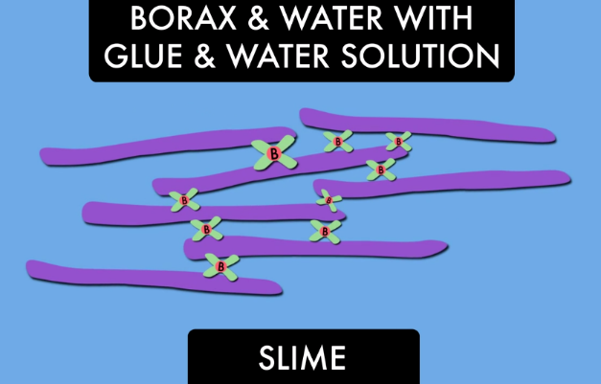
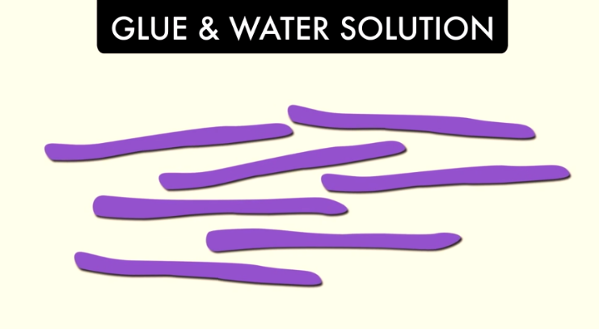

Additional Information:

Chart:
Sample Name: A
Amount of Glue: 1 tbsp
Amount of Borax: 3 tbsp
Properties:

How to extend: Have the students create their own mixtures of borax and glue. What is the lowest amount of borax you can add and still retain the qualities of a polymer?

